PROPOSAL TITLE: Arlington Equity Composite Indicators

Project Sponsor / Collaborator Community Progress Network (CPN) http://communityprogressnetwork.org/

Proposed Team Vicki, Stephanie, Brian, Josh (SDAL, member of CPN)
Nathanial Root (Data Analyst & Systems Architect), Jose Quinonez (Director of Community Impact), Cheryl Ramp (Director of Community Resources & Relations)
(APAH, member of CPN)

Project Description
- Project Summary There are three components for this project: literature review & web search, data discovery & exploratory data analysis, and composite indicator construction & visualization. Topics of the literature review include composite indicators in particular equity indicators relevant to the CPN mission. The web search will focus how other communities are constructing and using composite indicators with a focus on equity composite indicators. Based on the literature review, web search, and recommendations from Community Progress Network (CPN) members, the data discovery process will involve searching for and acquiring the data sources that will be used to construct the indicators. In addition, the data discovery process will involve introducing and training the students on the SDAL data framework process. The exploratory data analysis will involve descriptive statistics which includes the construction of the statistical properties of the composite indicators. The composite indicators will be constructed using an Arlington synthetic population. They composite indicators will be displayed using maps that identify statistically different census block groups. The individual indicators will be displayed using lollipop plots.
- Larger SDAL Project This project, as well as the DSPG project for the Roanoke & Alleghany Region, is part of the larger SDAL work on Community Learning through Data Driven Discovery. The plan is to coordinate with the Roanoke & Alleghany Region Project Team with regard to the literature search and construction of composite indicators so an urban-rural comparison can be made.
- Project Scope CPN is an Arlington advisory council of civic and business leaders, elected officials, service providers, nonprofits, and research institutions. The mission of CPN is to promote equity through education, engagement, and advocacy. The project will contribute to this goal by constructing a set of longitudinal composite indicators across multiple dimensions (for example, housing, education, transportation, and county services) at the census block group level.
- Importance to Sponsor The goal is to provide a set of equity composite indicators that can be used to educate and engage the public, advocate for equitable budgets and policy decisions, and monitor changes over time.
- Student Expectations The literature review and data discovery will be done simultaneously. This will not require any special skills on the part of the students. I have already created a Google Drive folder for composite indicator literature and web resources that the students can add to. The exploratory data analysis component will require students with computational skills and either have experience in constructing maps or a desire to learn. Constructing composite indicators with statistical properties will require students with coursework in statistical theory as will the construction of synthetic populations.

- The findings of the literature review and web search will be presented to CPN members by the end of June in a slide presentation.
- The discovery of data sources for the composite indicators that aligns with the literature review and web search and CPN recommendations (to be completed by the end of June).
- The construction of at least two composite indicators with estimates of their statistical properties (to be completed by the end of July).
- A slide presentation to CPN members in the first week of August on the baseline estimates of the composite indicators of equity and recommendations for future work.
- Minimum Number of Student/Fellows At least 1 fellow and 3 students

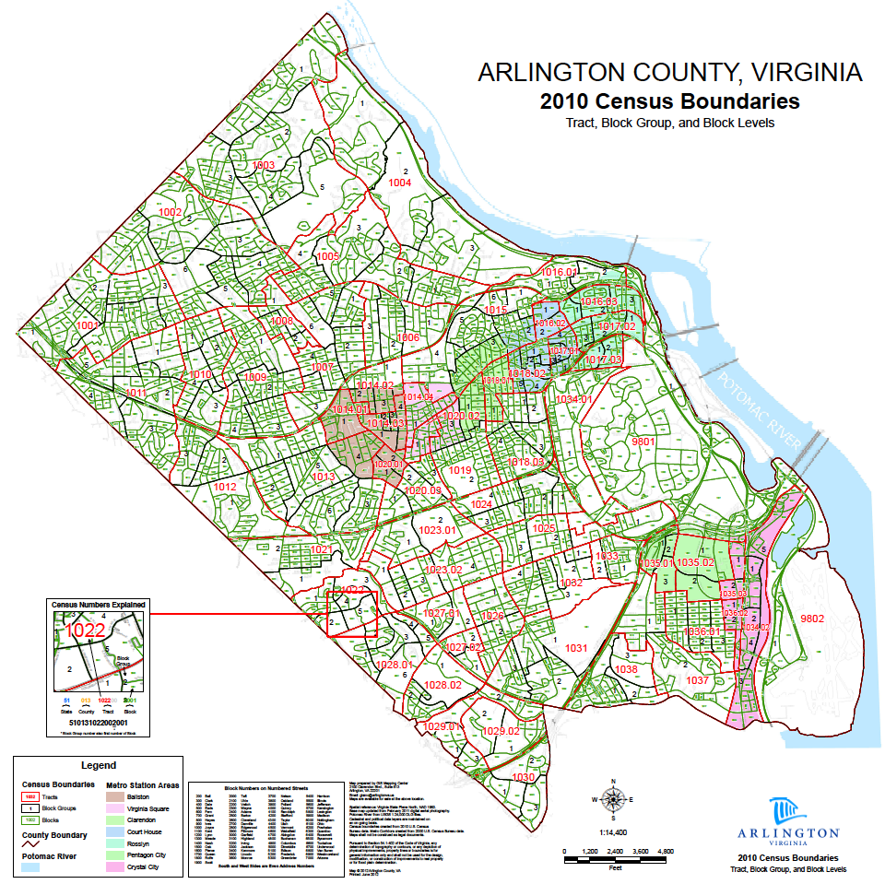

Composite Indicator is constructed from individual indicators (variables) aggregated into a single index base on underlying model of the multi-dimensional concept that is being measured. https://stats.oecd.org/glossary/detail.asp?ID=6278
Keller S, Nusser S, Shipp S, & Woteki, C (Spring 2018) Helping Communities Use Data to Make Better Decisions. Issues in Science and Technology, Volume XXXIV Issue 3, 83-89.

